Investigation Using Secondary Data to Observe Thermoregulatory Behaviour in Bird Species

Introduction
It is a common thought for individuals to have the conception that bird beaks are used for foraging, eating, enticing a mate, or perhaps even just a feature similar to hair, fingernails or toenails. The bird beak is non-insulated and is highly vascularised, making it efficient for heat transfer (Ryeland et al. 2017, p. 887). Interestingly, it has been discovered that birds use their bills or beaks to thermoregulate. In the warmer climates, such as environments closer to the equator, the bird beak sizes have adapted to be larger, this is because appendages lose heat. Having a larger beak in a warmer climate is an advantageous adaptation for birds to lose heat, as their bills/beak is highly vascularised and can lose heat easily. This means birds will not have an increase in internal body temperature, when the temperature in the environment around them increases. For example, in the toucan, 60% of heat loss is from its large bill size when it is resting (Ryeland et al. 2017, p. 885). Contrastingly, in cooler climates, bird beaks are smaller, so the species can conserve heat. This has also been observed and recorded in altitude changes. Bird beak thermoregulation and adapting to the climate by having larger or smaller beaks, has been observed in many species such as penguins, grouse, terns, gulls, barbets and parrots. This is known as Allen’s Rule.

Watch the video on Allen’s rule which relates to species of birds, who thermoregulate through their beak https://video.deakin.edu.au/media/t/0_mvi3uqs4 (Lim, Deakin University 2015)

Thermoregulation through bird beaks and bills is an adaptation birds have evolved to deal with the challenge of temperature change, to maintain the temperature of their internal environment. Species of birds have also developed a behaviour where they tuck their bill/beak into their plumage, this motion is known as ‘back rest’. The ‘back rest’ motion is what will be investigated throughout this activity.
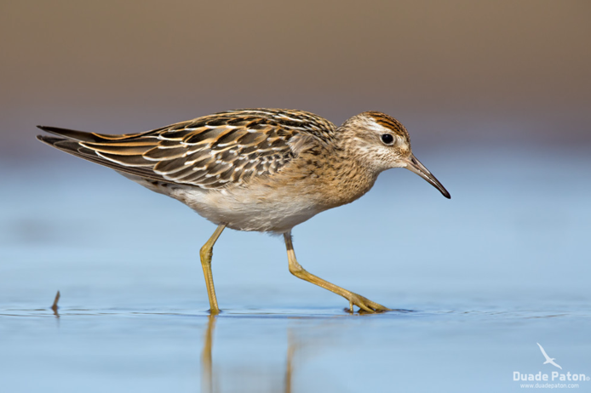
Background Information
Sharp-tailed Sandpipers are migratory birds which live on shores. They breed in Siberia and migrate a long way south, to Australia for their non-breeding season, from September to February (Adams, Museum Victoria 2016). The Sharp-tailed Sandpipers are found all throughout Australia during their migratory season. Sharp-tailed Sandpipers live in “shallow inland freshwater wetlands, mudflats, saltmarshes, mangroves, rocky shores and beach” (Adams, Museum Victoria 2016). This species exhibits the back rest motion, by tucking their thin beaks behind their plumage. Data on the frequency of the Sharp-tailed Sandpiper exhibiting this behaviour, and the temperature when this behaviour occurs is shown in the table on the next page.
Figure 1: A Sharp-tailed Sandpiper foraging for food. Sharp-tailed Sandpipers often feed on aquatic insects, molluscs, crustaceans and worms. (Adams, Museum Victoria, 2016)

Purpose
- To observe the frequency of the back rest behaviour in the Sharp Tailed Sandpiper species (Calidris acuminata)
- To consider why this behaviour is exhibited

What do you think the scientist’s hypothesis was when undertaking this data analysis?

Data
The data in each row shows a sharp-tailed sandpiper observed at a particular temperature. The second column shows what percentage of time the bird spent in back rest (which was recorded over a 20-minute observation whilst the bird was resting).

Temperature °C | % of time bird spent in backrest over 20-minute period
15.375 | 87.27515329
15.56 | 81.83446645
15.56 | 66.80224653
15.3 | 24.2212272
15.3 | 24.2255389718076
14.96 | 24.2255389718076
14.98 | 94.918682875668
14.98 | 27.1198213430816
16.1 | 47.0955448430812
16.1 | 85.9074081974129
24.5 | 94.33305852
24.5 | 53.8479876037983
20.9 | 71.5873900438061
20.9 | 68.9406818518492
27.7 | 0
27.7 | 0
23.9 | 16.9642028780281
23.9 | 13.9753311880777
31.52 | 5.36567808810826
31.52 | 3.49025818216719
30.42 | 63.1775061558829
30.42 | 19.3755597740798
35.48 | 0
35.48 | 0
36.02 | 4.81533705867285
36.02 | 13.173476975263
21 | 23.7221281965456
21 | 23.7806650732065
40.6 | 0
40.6 | 0
42.46 | 0
42.46 | 0
42.467 | 0
42.467 | 0
22.94 | 39.5932170752548
22.94 | 82.2091441913083
30.66 | 5.05282148844023
30.66 | 12.7705595784113
31.12 | 8.1986320733661
31.12 | 1.15291713578581
34.82 | 0
34.82 | 0

Results
In scientific reports and scientific journals, the raw data cannot be presented, instead a representation of this raw data should be shown, such as a scatterplot, bar chart, or table of values. For this data, we will be using a scatterplot to represent our data, then we will apply the Pearson’s correlation coefficient to measure the correlation between our x and y values.

- What is the independent variable? When plotting data on a graph on which axis will the independent variable go?

- Which is the dependent variable? Which axis will the dependent variable go on?

- Suggest a title for your graph.

- Using excel, create a scatterplot for the data. You can copy and paste the data from this document into an excel spreadsheet. To create the scatterplot:
- Select both columns of data
- In the ‘insert’ tab, go to ‘charts’, select ‘scatter’
- To change the title, click on the title to modify
- In ‘chart design,’ click on ‘add chart element,’ then ‘add axis titles’ to add in titles from your axis
- To add a trend line, go to ‘add chart element’ again, click on ‘trend line,’ then click ‘linear’

- Copy and paste your scatterplot below, including the elements listed above.

The Pearson correlation coefficient ‘r’ is a measure of the strength of the linear relationship between two variables. Pearson's r can range from -1 to 1. An r of -1 indicates a perfect negative linear relationship between variables, an r of 0 indicates no linear relationship between variables, and an r of 1 indicates a perfect positive linear relationship between variables.

- Calculate the Pearson’s correlation coefficient and write your answer below. To calculate, click ‘formulas,’ then ‘insert functions,’ search for ‘Pearson,’ click ‘insert function’ and highlight the two columns of data (not including the column headings).

- Interpret the Pearson’s correlation coefficient in terms of the two variables.

Discussion

- What is the trend of the data? What observations can you make about the data shown on the scatterplot?

- Using your knowledge on Allen’s rule and bird beaks, suggest why there is a positive/negative trend in the data? What conclusions can you suggest from this trend?

- Discuss how the backrest behaviour is a structural adaptation, a behavioural adaptation and a physiological adaptation. Which one is it most likely to be, and why?

- Suggest what the morphology of beaks would look like in bird species close to the equator, and contrast this with the morphology of bird beak sizes further away from the equator. Describe in your own words why this occurs.

- Researchers have observed bird species exhibiting the back rest behaviour in temperatures exceeding 40°C. Suggest a reason as to why the birds back rest their beaks when in extremely hot temperatures.

- Do you think that over the last 100-150 years, bird beak sizes (who demonstrate the Allen’s rule phenomena) would have grown larger or smaller? Suggest reasons why/why not and justify your reasoning.

