Solving Human Challenges Worksheet

Consider the following pictures. The first column shows a feature of an organism, the second column shows a human challenge it has solved. Your task is to describe how this feature solved the human challenge, and why? The first example is completed for you.
Organism | Human challenge it solved/invention created | How/why it solved the human challenge
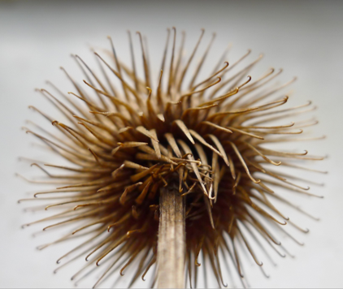  Burrs  Image source: http://www.publicdomainpictures.net/pictures/70000/velka/burr-whorl-velcro-inspiration.jpg | 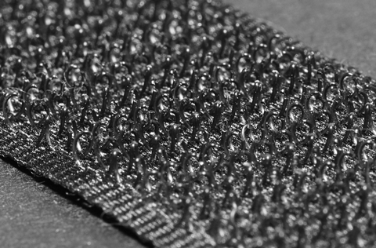  Velcro  Image source: https://commons.wikimedia.org/wiki/File:Velcro_Hooks.jpg | Burrs allowed two objects to be stuck together and to create a ‘zipperless fastener.’ (Greenwood et al. 2017, p. 156). This meant that items could be fixed or fastened together, and also be stuck together multiple times over (reusability).
Lotus Leaf  Image source: http://www.publicdomainpictures.net/pictures/70000/velka/burr-whorl-velcro-inspiration.jpg | Painting Outdoors  Image source: https://www.flickr.com/photos/49364825@N02/4729909285
Mosquito Proboscis/Mouthpart  Image source: https://commons.wikimedia.org/wiki/File:Mosquito_proboscis.JPG  Image source: https://en.wikipedia.org/wiki/File:Mosquito_Tasmania_crop.jpg | 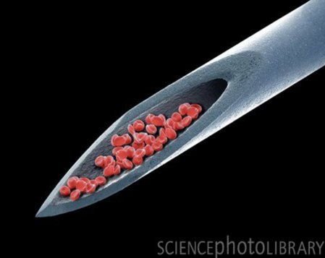  ‘Pain Free’ Needle Scanning Electron Micrograph  Image source:  https://imgur.com/gallery/JlUun
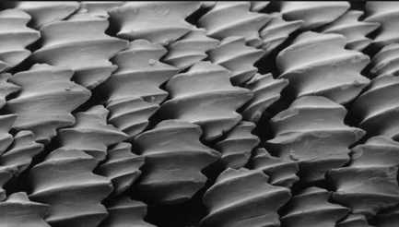  Sharkskin Scales (Denticles) Scanning Electron Micrograph  Image source:  https://commons.wikimedia.org/wiki/File:Denticules_cutan%C3%A9s_du_requin_citron_Negaprion_brevirostris_vus_au_microscope_%C3%A9lectronique_%C3%A0_balayage.jpg | 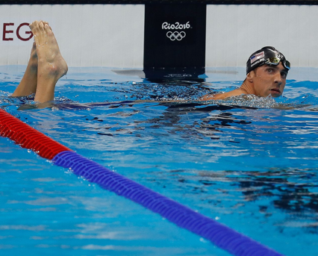  Sharkskin Swimsuit Was Worn By Michael Phelps (It is Now Banned)  Image Source:  https://commons.wikimedia.org/wiki/File:Denticules_cutan%C3%A9s_du_requin_citron_Negaprion_brevirostris_vus_au_microscope_%C3%A9lectronique_%C3%A0_balayage.jpg
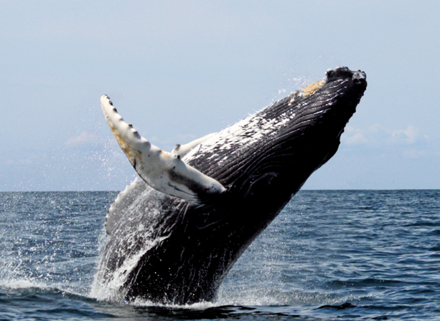  Whales- Ridges on Their Fins  Image source:  https://en.wikipedia.org/wiki/Baleen_whale | 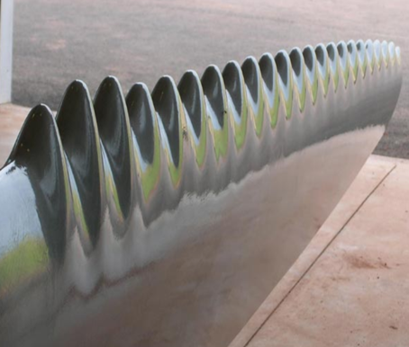  Wind Turbi Blade  Image source:  https://www.pinterest.com.au/pin/21532904438005478
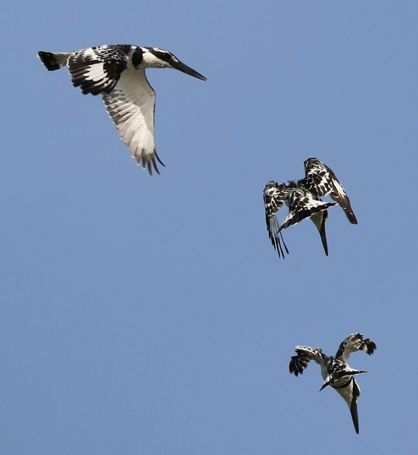  Kingfisher about to dive into water (Alcedo atthis)  Image source:  https://en.wikipedia.org/wiki/Template:POTD/2015-12-17 | 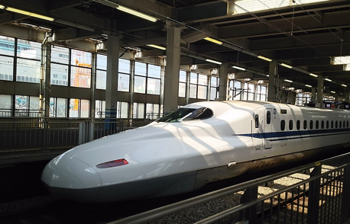  Shinkansen Bullet Train (Japan) Travels at 320km/h  Image source:  http://maxpixel.freegreatpicture.com/Bullet-Train-Tokaido-And-Sanyo-Shinkansen-Hiroshima-1918480

