Gardiners Creek Reserve – Fieldwork Data

Task 1 Naming and classifying invertebrates

Student Worksheet

Introduction
You will be provided with a spreadsheet showing data collected at two sites in a nature reserve next to a creek in inner-urban Melbourne (Gardiner’s Creek Reserve). You will see that the spreadsheet contains information that includes both scientific names and common names of animals called invertebrates.

Pitfall traps were used to collect the data. A pitfall trap is simply a small tube-shaped container without a lid that is buried in the ground. Several traps are placed randomly in the environment to be studied. The traps are left for a period of time and then the specimens that have fallen into the traps are identified and counted.

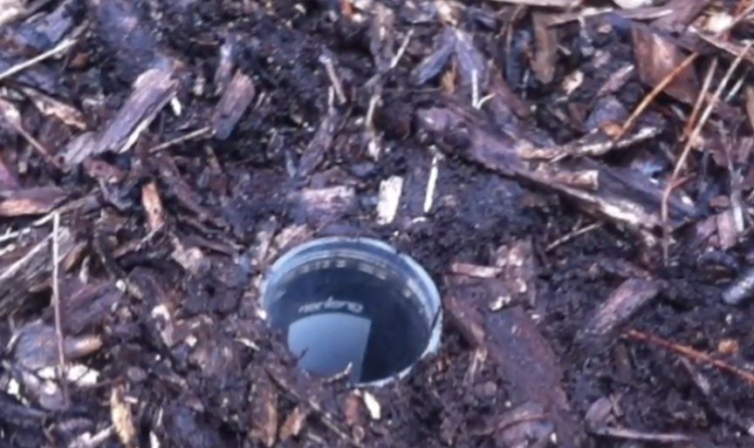

The aim of this task is for you to learn about common invertebrates (animals without backbones) that are found in a nature reserve in inner Melbourne, their common names and scientific names. The scientific names are related to the classification of the animals. Animals with the same common name do not necessarily belong to the same species and hence have the same scientific names.

You may have studied the scientific naming of living things. Living things are classified according to characteristics they share in common. The biggest groups are the Kingdoms. Kingdoms are divided into Phyla (singular Phylum), The Phyla into Sub phyla and/or Classes, the Classes into Orders and so on down till we get to Species.

In this exercise, you will be using the groups known as Subphyla, Classes and Orders. Many different insects (Class - Insecta) have been collected. To make sense of them we divide up the insect specimens according to the Order to which they belong. The specimen might be a grasshopper (Order - Orthoptera) or an ant (Order - Hymenoptera).

Instructions
Look at the left-hand column of the spreadsheet. Here you will see a list of the invertebrate organisms that could be found in a creek reserve. (Note: not all of these types of organisms were found)

Compete the table on the next page and answer the questions.

Common names of invertebrate
Write the scientific name and common names. Place a tick in the column to indicate whether the scientific name is a phylum name, a subphylum name, a class name or an order name. Finally describe the characteristics of organisms that share this name. If you are using a computer you may wish to insert an image into the table.

Scientific Name | Phylum | Sub Phylum | Class | Order | Common name | Description or image

Questions

- What characteristic/s do all invertebrates share?

- How many different classes of invertebrates were found at the Reserve?

- What characteristics do all insects share?

- How many different orders of insect were found in the Reserve?

- What characteristics are used to distinguish the different orders of insects?

- a. To what phylum do the Crustacea, Arachnids and Insects belong?

b. What characteristics of each of these types organisms share that enable them to be classified into the same Phylum?

- Why do scientists usually use the scientific names for organisms rather than common names?

