Module 1: Diagram of Epithelial to Mesenchymal Transition

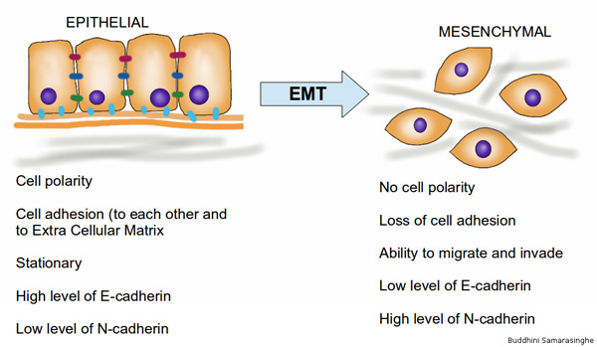

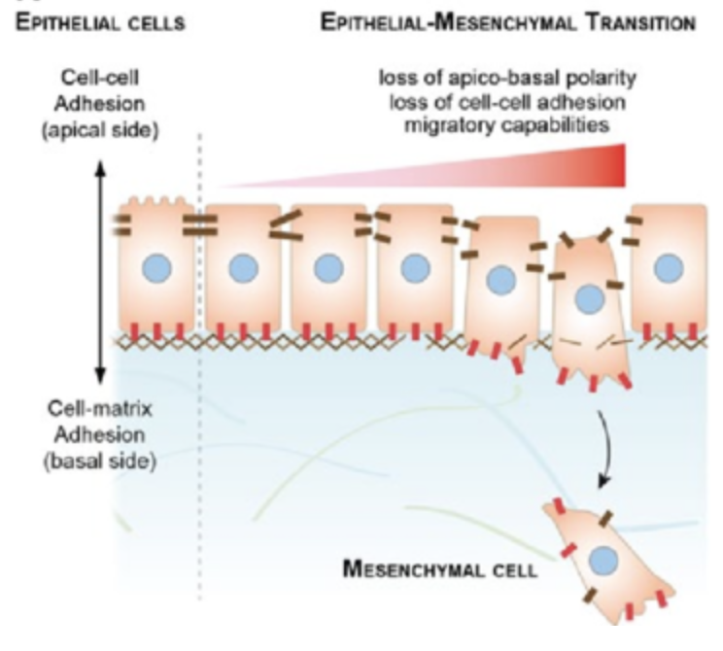
https://www.researchgate.net/figure/234123855_fig1_Fig-1-epithelial-mesenchymal-transition-and-epithelial-collective-migration-a

