Sequence 1, Activity 2.1 Student Copy

Cytotoxic T cell |  | is a molecule found on the surface of T cells, or T lymphocytes, that is responsible for recognizing fragments of antigen as peptides bound to major histocompatibility complex (MHC) molecules
Granzymes |  | These cells are effector T cells. When activated by antigen and cytokines, they kill target cells that express the same antigen.
T-cell receptor (TCR) |  | Are molecules, usually proteins or carbohydrates, which are expressed on the cell wall of a target cell, are able to bind to T cell receptors that target these specific molecules.
Serial killing |  | Is an effector cell that has been genetically modified to express chimeric antigen receptors that actively seek out specific cancerous target cells
antigen |  | Are a family of protease (enzymes which breaks down proteins and peptide) that reside within the target cell, and are activated by granzymes released by cytotoxic T cells. They play an essential role in a target cell’s programmed cell death.
Perforin |  | Are proteases (enzymes which breaks down proteins and peptide) that are released by cytoplasmic granules within cytotoxic T cells. They activate caspases, resulting in the programmed cell death of the target cell.
CAR T-cell |  | A pore forming cytolytic protein found in the granules of Cytotoxic T lymphocytes (CTLs) and NK cells. It binds to the target cell's plasma membrane and ‘punches’ pores on the target cell enabling granzymes to enter.
Caspase |  | A genetically modified T cell receptor, that is able to bypass the MHC complex on a target cell, recognizing antigens presented on target cell surfaces
CAR T-cell receptor |  | The ability of a T cell to initiate self-destruction of a target cell, detach itself and then seek out and destroy new target cells.

Sequence 1, Activity 2.1 Teacher Copy
Cytotoxic T cell |  | is a molecule found on the surface of T cells, or T lymphocytes, that is responsible for recognizing fragments of antigen as peptides bound to major histocompatibility complex (MHC) molecules
Granzymes |  | These cells are effector T cells. When activated by antigen and cytokines, they kill target cells that express the same antigen.
T-cell receptor (TCR) |  | Are molecules, usually proteins or carbohydrates, which are expressed on the cell wall of a target cell, are able to bind to T cell receptors that target these specific molecules.
Serial killing |  | Is an effector cell that has been genetically modified to express chimeric antigen receptors that actively seek out specific cancerous target cells
antigen |  | Are a family of protease (enzymes which breaks down proteins and peptide) that reside within the target cell, and are activated by granzymes released by cytotoxic T cells. They play an essential role in a target cell’s programmed cell death.
Perforin |  | Are proteases (enzymes which breaks down proteins and peptide) that are released by cytoplasmic granules within cytotoxic T cells. They activate caspases, resulting in the programmed cell death of the target cell.
CAR T-cell |  | A pore forming cytolytic protein found in the granules of Cytotoxic T lymphocytes (CTLs) and NK cells. It binds to the target cell's plasma membrane and ‘punches’ pores on the target cell enabling granzymes to enter. 6
Caspase |  | A genetically modified T cell receptor, that is able to bypass the MHC complex on a target cell, recognizing antigens presented on target cell surfaces 9
CAR T-cell receptor |  | The ability of a T cell to initiate self-destruction of a target cell, detach itself and then seek out and destroy new target cells.

Sequence 1, Activity 2.2: T cell killing of target cells

Cut out the statements from the diagram below. They are out of order. Arrange these states next to the numbers (1-5) in the correct order

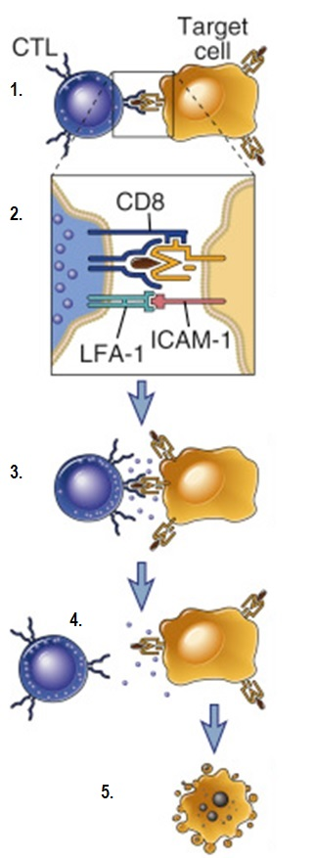
After delivering the lethal hit, the CTL is released from the target cell, which usually occurs even before the target cell goes on to die. The CTL seeks out further target cells expressing the same antigen as part of its serial killing ability.

With activation, the CTL releases cytoplasmic granules which are transported along microtubules (also known as the centrosome) and are released between the plasma membrane of the CTL and target cell. The cytoplasmic granules contain enzyme proteins such as granzymes and perforin, which deliver the ‘lethal hit’ to the target cell.

The CTLs binds to the target cell by its antigen receptor, co-receptor (CD8) and adhesion molecules. To be efficiently recognized by CTLs, target cells must express class I MHC complex, which bind to both the T cell receptor (TCR) and CD8 co-receptor.

The perforin ‘punches’ holes in wall of the target cell, and the granzymes interact with caspases within the target cell. The caspases degrade the target cell’s DNA. Both activities initiate cellular responses that result in the death of the target cell, in a process known as apoptosis.

Effector T_{c} cells (CTLs) migrate to tissues at the site of tumor growth. The CTL detect the antigen presented on the target cell, binds to the target cell and is activated.

Sequence 1, Activity 2.2: T cell killing of target cells (teacher’s copy)

Effector T_{c} cells (CTLs) migrate to tissues at the site of tumor growth. The CTL detect the antigen presented on the target cell, binds to the target cell and is activated.

The CTLs binds to the target cell by its antigen receptor, co-receptor (CD8) and adhesion molecules. To be efficiently recognized by CTLs, target cells must express class I MHC complex, which bind to both the T cell receptor (TCR) and CD8 co-receptor.

With activation, the CTL releases cytoplasmic granules which are transported along microtubules (also known as the centrosome) and are released between the plasma membrane of the CTL and target cell. The cytoplasmic granules contain enzyme proteins such as granzymes and perforin, which deliver the ‘lethal hit’ to the target cell.

After delivering the lethal hit, the CTL is released from the target cell, which usually occurs even before the target cell goes on to die. The CTL seeks out further target cells expressing the same antigen as part of its serial killing ability.

The perforin ‘punches’ holes in wall of the target cell, and the granzymes interact with caspases within the target cell. The caspases degrade the target cell’s DNA. Both activities initiate cellular responses that result in the death of the target cell, in a process known as apoptosis.

Information and illustrations adapted from Abbas, Lichtman & Pillai 2015

Student Handout: T cell receptors (TCR) and chimeric antigen receptors (CAR)

Cytotoxic T cells (T_{c}) are T-cell lymphocytes that have been activated. Cytotoxic T cells express T-cell receptors (TCRs) on the cell wall that are able to recognise a specific antigen. An antigen molecule is a substance that stimulates an immune response in the body, and is often produced by cancer cells.

The antigens in a cancerous cell are broken down and become bound to a class 1 MHC and presented on the surface of the cancerous cell. A cytotoxic T cell with a specific antigen receptor will bind to a class 1 MHC where they are recognized by the T cell. In order for the TCR to bind to the class I MHC molecule, the TCR must be accompanied by a glycoprotein called CD8, which binds to the constant portion of the class I MHC molecule on the target cell. Therefore, these T cells are also called CD8+ T cells.

Figure 1. The TCR of a T cell connects to the MHC complex in the antigen presenting cell (APC), a cancer cell (Srivastava & Riddell 2015)
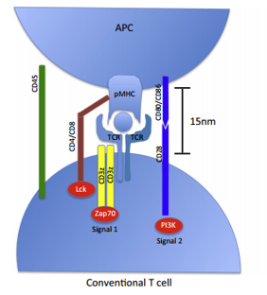
The connection between CD8 glycoprotein and the MHC molecule keeps the TC cell and the target cell bound closely together during antigen-specific activation. CD8+ T cells are recognized as TC cells once they become activated.
In contrast, the chimeric antigen receptor (CAR) that has been genetically modified and expressed on a patient’s own effector T cells, are modified to bypass the need for antigens to be presented on the MHC I complex.
Figure 2. The CAR of a T cell connects direct to the antigen presented on the outside of a cancer cell (Srivastava & Riddell 2015)
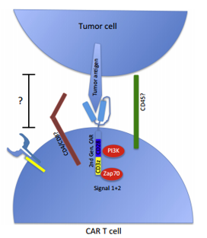
(Srivastava & Riddell 2015)
Many cancers avoid normal immune responses, as the cell is able to ‘trick’ itself into believing that it is a healthy cell. In this instance, the cell does not present any antigens on the MHC complex, as it does not recognise any foreign material in the cell. When using a CAR receptor on a T cell, it avoids the need for the target cell to present foreign material on the MHC complex. It is able to detect the tumour antigens expressed directly on the cell wall.
T cells engineered with chimeric antigen receptors (CARs) have been designed from an understanding of TCR signalling.
Figure 3. Chimeric Antigen Receptor
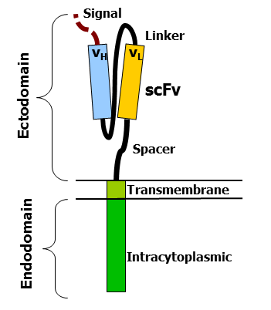
(Source: Mxpule 2011 ( CC-BY-SA 3.0))
The Endodomain is made up of signalling molecules that are found on normal TCRs. The Ectodomain is the domain exposed on the outside of the T cell. It has an antigen recognition region which is made up of segments of single chain variable fragments (svFv), which are pieces of antibodies connected together to identify and connect to specific antigens presented on a cancer cell surface.

Changes to Chimeric Antigen Receptors (CAR) on effector T cells
Research in science is always looking for ways to improve the effectiveness of treatments in cancer. One example is the changes to the chimeric antigen receptor configuration. There have been three generations of CARs that have evolved (Figure 4).

Figure 4. First (1G), second (2G) and third (3G) generation CARs
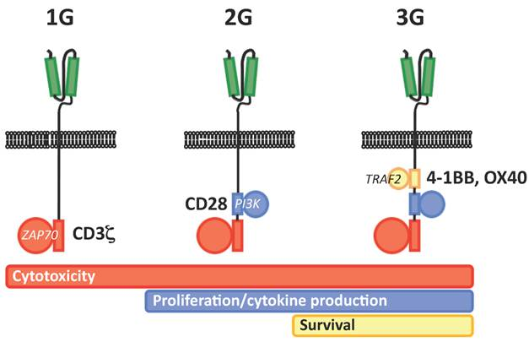
(Image: First, second and third generation CARs, image in public domain)
First generation CARs typically had the intracellular domain from the CD3 ζ- chain, which is the primary transmitter of signals from normal TCRs. This CD3 helps to activate the cytotoxic T cell.
With the second generation CARs, intracellular signalling domains from various costimulatory protein receptors were added to the cytoplasmic tail of the CAR to provide additional signals to the T cell. Scientists identified that the second generation improves the antitumor activity of T cells. This means that second generation CAR T cells were better able to regenerate and proliferate in a person’s body when needed as part of an adaptive immune response.
More recent, third generation CARs combine multiple signalling domains, enabling them to not only proliferate when required, but also maximise their own long-term survival in the human body.
So in summary, the CAR-modified T cells can recognize tumour cells via binding of the CAR to its tumour antigens presented on the tumour cell surface, independent of the need for a TCR-MHC interaction (Figure 5). As a result T cells are activated and can efficiently eliminate tumour cells by the secretion of perforin and granzymes as well as through the signalling pathway in the synapse. In addition, other tumour-infiltrating immune cells can be activated by the secretion of various cytokines as part of the adaptive immune response.
Figure 5. CAR T cell and tumour cell interaction
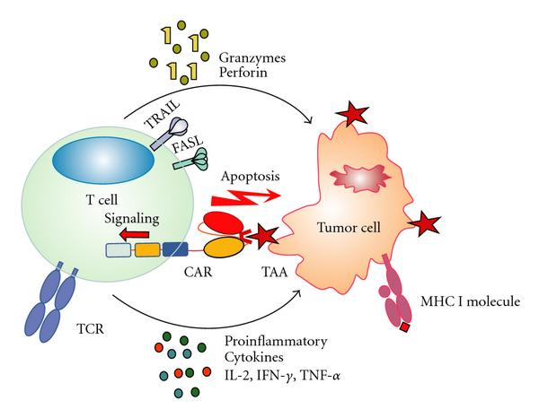
(Image: Unknown n.d.,)

Sequence 1, Activity 2.7: Visual Organizer
Video | Questions
 | Research Outline  - What is the purpose?  - What is their hypothesis?  - Why is the research important? | Research predictions & findings  - What did they hope to determine from their research? (predictions)  - What did they find from their research? (outcomes) | Implications  - How can this knowledge help with improving T cell immunotherapies?  - What other questions does this research raise in relation to T cell immunotherapy?
1
2
3
4

Sequence 1, Activity 3.1 Adaptive Immunity Word List

Macrophage lymphocyte Tcell
cytotoxic helper effector
memory cell replication dendritic
cell-mediated humoral Bcell
antigen-presenting antibodies antigens
cytokines interleukin adaptive
acquired MHC target cell
pathogens perforin Immunity

Sequence 2, Activity 2.1: Monoclonal Antibody Production
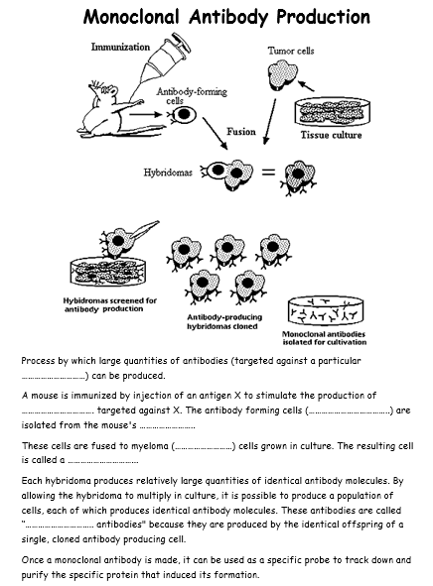
(Source: Teach Biology 2010, Monoclonal Antibodies, TES Australia, retrieved 29 October 2016, <https://www.tes.com/teaching-resource/monoclonal-antibodies-6050588>.)

