Producers – who’s munching all the plants?

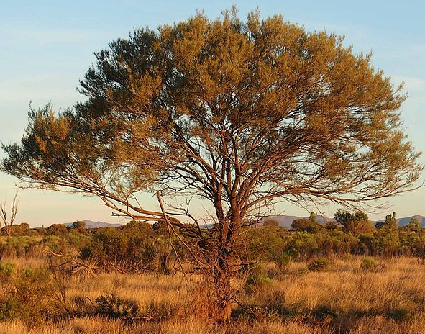
Ecologists know that rabbits munch their way through plants at an extremely rapid rate. Since many small native mammals are extinct, ecologists didn’t really know what impact native mammals would have on plants in the absence of rabbits. Perhaps they would also munch through massive amounts. At Arid Recovery ecologists had both environments – one with rabbits and few natives and one with no rabbits and reintroduced natives. Now they could compare these two environments to see how rabbits impact plants compared to native mammals.
Fenced reserve at Arid Recovery

- Rabbits
- Few native mammals
- No rabbits
- Reintroduced native mammals

Mulga tree. Credit: Mark Marathon
- Imagine you’re an ecologist working at Arid Recovery. As shown above, you have a fenced reserve that keeps rabbits and other non-natives out. Small native mammals that eat plants have been reintroduced. Outside the reserve there are rabbits and few native mammals. You want to find out how rabbits and native mammals compare in terms of their impact on plants. What is your hypothesis?

- Ecologists use many different methods to test their ideas and gather data. How might you go about testing your hypothesis?

- Ecologist Dr Nicki Munro also designed an experiment to explore this question. Watch this clip to learn how she designed her study and why.

Let’s explore some of Nicki’s results for Mulga.
Year | Inside | Outside
2001 | 31 | 3
2003 | 66 | 2
2006 | 87 | 2
Plot these results on a graph. Mulga is typical of all the plant species Dr Munro looked at. Does this match your hypothesis?

- The density and number of a prey species are determined by the density and number of a species that prey on them. In this case, which is the prey and which the predator?

