Mulga tree  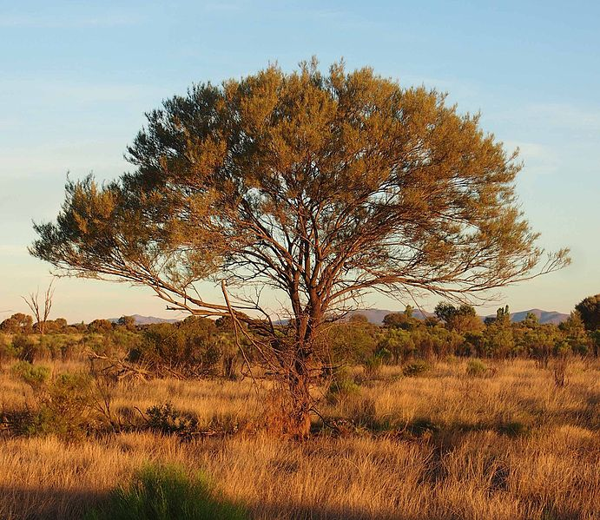 | Mistletoe  Grows on other trees, taking water and nutrients from the tree, providing nothing in return
Mistletoe bird  Eats nectar from mistletoe and inadvertently pollinates mistletoe in the process | Bettong  Eats the fruit of the fungi without harming the fungi and spreads the spores  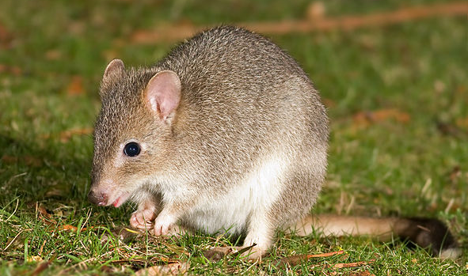
Dingo  Apex predator that eats lots of small mammals  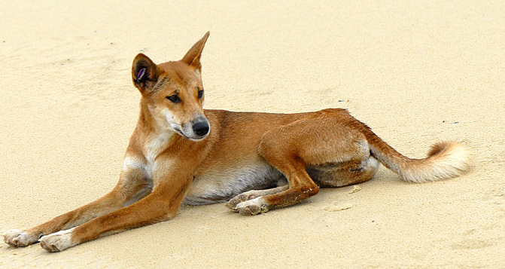 | Grass  There are many types of grasses in the arid zone  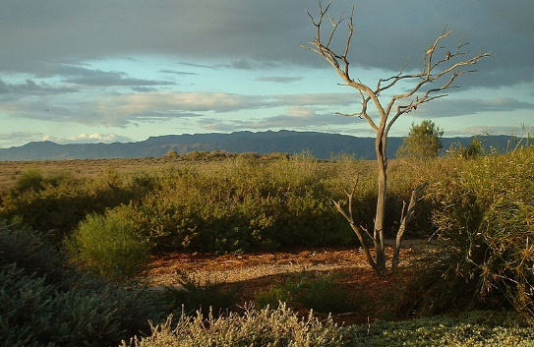
Ectomycorrhizal fungi  Grows on tree roots, using carbon from the tree and the tree takes phosphorous and nitrogen from the fungus  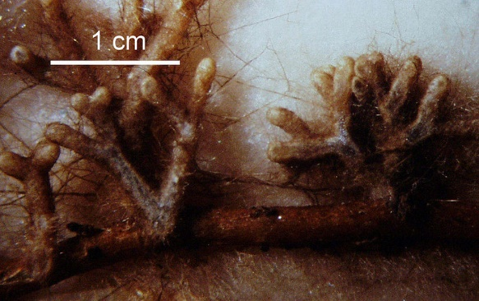 | Shingleback lizard  Shelters from heat and predators in burrows dug by bettongs. Bettongs don’t appear to gain from this, but don’t seem to mind either.  